**ZIMBABWE SCHOOL EXAMINATION COUNCIL**



**General Certificate of Education Advanced Level**

**COMPUTING 6023/3**

**KWEKWE LIBARY MANAGEMENT SYSTEM**

**BY**

**TAKUDZWA A. SVOSVE**

**050304 /5137**

**THIS RESEARCH PROJECT IS SUBMITED IN PARTIAL FULFILMENT OF THE REQUIREMENTS OF THE ZIMSEC GENERAL CERTIFICATE IN EDUCATION ADVANCED LEVEL COMPUTING**

**NOVEMBER 2020**

**TABLE OF CONTENTS**

1. SECTION A: SELECTION, INVESTIGATION AND ANALYSIS 1

1.0 INTRODUCTION 1

1.1 BACKGROUND OF THE STUDY 1

1.2 INVESTIGATION OF THE EXISTING SYSTEM 2

1.3 FEASIBILITY STUDY 2

1.4 REQUIREMENTS SPECIFICATION 8

1.5 AIMS AND OBJECTIVES 11

2. SECTION B: DESIGN 12

2. 0 INTRODUCTION 12

2.1 CONSIDERATION OF ALTERNATIVES 12

2.2 JUSTIFICATION OF THE ALTERNATIVES 15

2.3 INPUT DESIGN 15

2.4 DATA STRUCTURES 18

2.5 ENTITY RELATIONSHIP DIAGRAMS 20

2.6 OUTPUT DESIGN 21

2.7 OVERALL PLAN 22

3. SECTION C: SOFTWARE DEVELOPMENT 24

3.1 TECHNICAL DOCUMENTATION 24

3.1.1 Pseudo-code 24

3.1.2 Flow Charts 25

3.2 PROGRAM LISTING 27

Add new products 30

Managing staff members 31

3.3 USER DOCUMENTATION 41

4. SECTION D: TESTING AND EVALUATION 46

4.1 USER TESTING 46

4.2 SYSTEM TESTING 49

4.2.1 Ease of use 49

4.3 SYSTEM STRENGTHS 49

4.4 LIMITATIONS 49

4.5 EVALUATION OF THE SYSTEM 49

**SECTION A: SELECTION, INVESTIGATION AND ANALYSIS**

**INTRODUCTION**

In this modern day and age, it is idyllic for any organization which handles large volumes of data to have a computerized system to input data, process it and present the required results, in the desired form as and when statutory. The various sectors can have specialized systems for their particular section of the organization, but these systems would be contributing towards the core values, objectives and mission of the organization. With the current technological trends, it has become fundamental to have a system or subsystems of an organization with a centralized database so as to consolidate data and information security.

**1.1 BACKGROUND OF THE STUDY**

The Kwekwe Library, located in Kwekwe, is a library for the community of Kwekwe at large as its name clearly vetoes. It was established back in the year 1995, in recognition of the new government of Zimbabwe after the colonial era, which advocated for the right of all to learn, irregardless of gender, tribe or race. By then, learning resources such as textbooks, novels and the likes were very scarce hence it was built to ease access to the previously mentioned resources for Kwekwe locals. To date, it still serves its sole purpose of easing access and also serves as a quiet place where Kwekwe locals can read in peace.

**1.2 INVESTIGATION OF THE EXISTING SYSTEM**

**PROBLEMS IN THE CURRENT SYSTEM**

As a library which caters for the whole community at large, staff members tend to suffer from the manual system used by the organization. All of the registered members’, suppliers’ and staff records are hand written which gives rise of errors as some records may be left out or may be wrongly captured or may be misinterpreted due to long hours of work. In addition, production of accurate reports is as nearly as impossible also due to the fact that the records are handwritten.

**System Flowchart**



**1.3 FEASIBILITY STUDY**

The researcher carried out a feasibility study in order to ascertain the need for coming up with the new system and determining whether it is possible to come up with the new system. The following is the feasibility study report:

**1.4.1 Technical Feasibility**

After the collection of data at fact finding, the organization was sure that they are able to purchase the necessities needed for the development of this system. The basic necessities were put into two categories which are; Hardware and Software. The organization was also confident that it would be able to train its staff members on how to use the system.

**1.4.2 Economic Feasibility**

This system will be remarkably beneficial weighed against the former system since there are outcomes which out-weigh the costs involved in developing, installing and maintaining the new system. These benefits that accrue from the introduction of the new system have also indicated that they outweigh the costs to be incurred. Below is a summary of the benefits;

TANGIBLE AND QUANTIFIABLE BENEFITS

* Few processing errors
* Increase production
* Increase response time
* Benefits in terms of monetary values

INTANGIBLE BENEFITS

* Improve borrower goodwill
* Employee moral
* Job satisfaction

**1.4.3 SOCIAL FEASIBILITY**

This system will be exceptionally taken into consideration by the locals since it does not alter their morals, values and norms in the society. It will not leave any workers jobless but instead, help workers specialize in their field of work, hence workers will perfect their work.

**1.4.4 LEGAL FEASIBILITY**

The new system will not violet the legal requirements of the state. Laws of Data Protection Act will be followed as they are.

**1.4.5 SCHEDULE FEASIBILITY**

As the system analyst, the project will need some time for research which takes the program a long time before the system is developed, which takes about three months. The period of the program is also dependent of the organization. The longer the organization takes to buy the equipment needed for the system, the longer the system’s development period.

**Questionnaire for the Workers:**

1. What type of a Library system are you using?

Manual Computerised

1. Does your system consume time when using it?

YES NO

1. If so how much time does it take?

Few Hours Week

1. In terms of simplicity how do you describe your system?

Simple and easy Quite Complex

1. What security measures does your system offer?

Lock and Key Safe House

1. When using your current system, do you face any problems?

YES NO

1. Does your system have back up plan?

YES NO

1. Do you have problems in retrieving your backup information?

YES NO

1. Do you have other problems that you face during the operation of your current system?

YES NO

1. Are you interested in being introduced to a new computerised system in your organisation?

YES NO

What are the problems that you face when retrieving back up information to create reports?

………………………………………………………………………………………………………………………………………………………………………………………………………………………………………………………………………………………………………

What ideas have suggested to the Management department in order to improve the current manual system?

………………………………………………………………………………………………………………………………………………………………………………………………………………………………………………………………………………………………………

What features and recommendations do you have for the new computerised system?

……………………………………………………………………………………………………………………………………………………………………………………………………………………………………………………………………………………………………....

**Questionnaire for the Management:**

1. What type of a system are you using?

Manual Computerised

1. How long have you been using your system?

Over 5 years Over 10 years

1. State the speed of your current system

Fast Slow

1. How accurate is the current system?

Not accurate enough Very accurate

1. Is your current system user-friendly?

Yes No

1. What are your workers saying about the system in terms security?

Secure Not Secure enough

1. Have your workers encountered problems during the operation of your current system?

Yes No

1. Have you come up with ideas in order to overcome the problems being encountered?

Yes No

1. Are you interested in introducing the new computerised library management system to the organisation?

YES NO

1. Do you think that moving to the computerised system will help to overcome the problems?

Yes No

What are the disadvantages of your current system?

……………………………………………………………………………………………………………………………………………………………………………………………………

What do you think are the advantages of moving to the new computerised system?

……………………………………………………………………………………………………………………………………………………………………………………………………

What features and recommendations do you have for the new computerised system?

……………………………………………………………………………………………………………………………………………………………………………………………………

**INTERVIEW QUESTIONS FOR WORKERS**

1. What kind of information is entered in the system?
2. What methods do you use in collecting the information to be used in the system?
3. After the collection, what happens during the operation of the system?
4. What are the problems that you face in performing all the tasks manually?
5. How is the information stored after the operation of the system?
6. How do you retrieve the stored information when you want to produce reports?
7. What are the problems you face retrieving the stored information?
8. What tasks do you perform in preparing reports for the management?

**INTERVIEW QUESTIONS FOR MANAGEMENT**

1. Do you think that your current system is ideal?
2. What are your views on the current system?
3. What kind of information is required so that it can be used in the system?
4. What challenges are the system users encountering in performing the task of collecting information from workers?
5. Have you ever considered the ideas that your workers suggest in solving the problems that are being caused by the system?
6. What ideas do you have towards the system?
7. What has been done so far to reduce the problems and for the system users to produce good reports?
8. Are you willing to change your system?

**1.4 REQUIREMENTS SPECIFICATION**

**USER REQUIREMENTS**

In the investigation carried out during the preliminary study of the system, the analyst managed to gather information about what the users expected the system to be like. It was also at this stage that they highlighted how they preferred some of the tasks to be accomplished. Generally, the users required a system;

* that is user friendly and reliable in all aspects.
* that is accurate and efficient thereby making calculations with no errors in the least possible time so as to avoid repetition of work.
* that is secure, allowing users to change their login passwords whenever they feel their security has been compromised.
* that stores files and records in a central place to allow for easy access, navigation and use by all eligible system users.
* that should be able to produce reports at any given point in time with the least amount of effort from the user satisfying any given criteria of reporting as and when the report is required.
* that should enable faster updating of records and reduce search time; with the records occupying the least space possible.
* that completely gets rid of manual searching of and entering borrowers’ records.

**Software requirements**

* For documentations: (Microsoft Word 2019)
* For creating the database: (Microsoft Access 2019)
* Developing the application: (Visual Basic 2012)
* Updated antivirus software (Avast, Norton, Avira, Byte-fence)
* .Net Framework

**Hardware Requirements**

**Input devices:**

* Mouse - Allows navigation through the system
* QWERTY Keyboard - Allows data to be entered by pressing keys.
* Rear camera – for capturing pictures for facial recognition

**Output devices**

* LCD 15” Monitor - Displays entered data and also used in verification of data
* Printer - Produces output reports, forms, receipt

**Storage devices**

* A minimum hard disk space of one terabyte (1 TB)
* External hard drives for backup
* Random Access Memory (8 GB)

**Processor**

* More than 3.20 GHz

**1.5 AIMS AND OBJECTIVES**

**AIMS**

* To increase accuracy of the system.
* To ensure security of data.
* To increase speed of file generation.

**OBJECTIVES**

* To provide a full range of reports that will satisfy informational requirements.
* To develop a system that is accurate in terms of calculations.
* To develop a system that is secure in terms of security.
* To develop a system that is fast and efficient.
* To develop a system that updates information faster compared to manual system.
* To develop a system with improved data retrieval.

**EVIDENCE OF RESEARCH**

See appendices

**SECTION B: DESIGN**

**2. 0 INTRODUCTION**

This phase focuses on the design of the proposed system; the design being based on the findings of the analysis of the current system. Its main focus is on how the system functionality is to be provided by different components of the proposed system in terms of the system structure, database as well as the program structure. It gives an outline of the Physical design, the Input design, Process design, Output design, Dialogue design and Database design. It outlines all the design needed for the proposed system. All the design for input and output forms and design for system interface as well as the design or data attributes is done in this phase.

**2.1 CONSIDERATION OF ALTERNATIVES**

1. Buying a software package e.g. an off the shelf package.
2. Integrated software applications.
3. Implementing a customised software package.

**2.1.1 ALTERNATIVE 1**

**Off the shelf package**

The analyst took considerations to see whether it was worthwhile to buy an already developed system because this requires the purchase of compatible hardware and software being purchased; also, technical expertise may be needed for the maintenance and installation of that system. After analysing this option, I came up with the following advantages and disadvantages:

**Advantages**

* The software can be bought and installed straight away.
* The software is tried and tested and likely to contain fewer bugs than newly written software.

**Disadvantages**

* The software can potentially be very sophisticated because of the resources that are put into its development so user training on how to use the new system will be required.
* The packaged system is expensive and may not interface well with other systems.
* Adjustments may be needed: you may have to alter the way that you work in order to fit in with the software’s capabilities. You may also need to take time to learn how to use the software properly.

**2.1.2 ALTERNATIVE 2**

**Integrated software application packages**

Integrated software is a single program that contains "modules" for many popular business applications such as word processing, spread sheet, database management, graphics and communications. The user can easily switch from one type of application to another without exiting the program or it is a tightly interconnected suite of several application programs that share a common database and user interface. After analysing this option, I came up with the following advantages and disadvantages:

**Advantages**

* Low cost
* The ability to share information between modules

**Disadvantages**

* Each module is limited to basic functions
* May not be compatible with other popular business software
* Not suited for large companies or professional use

**2.1.3 FINAL CHOICE**

**Implementing a customized software package**

Customized software, sometimes known as personalization, consists of tailoring a service or a product to accommodate specific individuals, sometimes tied to groups or segments of individuals. A wide variety of organizations use a customized software to improve [member satisfaction](https://en.wikipedia.org/wiki/Customer_satisfaction), digital payment and as well as for advertising. The system is typically created because it can produce a unique model for a unique firm.

**Advantages**

* The system will be custom-developed and therefore more relevant to the Kwekwe Community Library needs.
* The software being customized; the enterprise may have to engage a software engineer to maintain it. In other words, the problems faced can be countered immediately.
* Well trained users use the software and therefore they can maximize software utilization.
* Business information is easier to understand because customized software incorporates your business known-how.
* It is also easy to use because it works the way the user wants.

**Disadvantages**

* Custom development is time consuming.

**2.1.4 Justification of the final choice**

The customized software package was voted and recommended as the best solution to address the problems faced at Kwekwe Community Library. Even though the method is costly to develop, the Organization has decided to spread its funds to develop this system since it brings about so many benefits to the organization now and in the future. It also addresses the current problems of the organization. The system is flexible to updating if there is an increase in technological use, thus it can be updated in units in case of change. It turns to shrink hefty amounts associated with labour, paper work and others.

**2.3 INPUT DESIGN**

**Data Capturing Forms:**

**Login Form**

|  |  |  |  |  |  |  |  |  |  |  |  |  |  |  |  |  |  |  |
| --- | --- | --- | --- | --- | --- | --- | --- | --- | --- | --- | --- | --- | --- | --- | --- | --- | --- | --- |
| LOGIN INTERFACE | | | | | | | | | | | | | | | | | | |
| USERNAME | |  |  |  |  |  |  |  |  |  |  |  |  |  |  |  |  |  |
|  | | | | | | | | | | | | | | | | | | |
| PASSWORD | |  |  |  |  |  |  |  |  |  |  |  |  |  |  |  |  |  |
|  | SAVE |  | | CLEAR | | | |  | | EXIT | | | |  | | | | |

**ADD NEW USER FORM**

|  |  |  |  |  |  |  |  |  |  |  |  |  |  |  |  |  |  |  |
| --- | --- | --- | --- | --- | --- | --- | --- | --- | --- | --- | --- | --- | --- | --- | --- | --- | --- | --- |
| NEW USER INTERFACE | | | | | | | | | | | | | | | | | | |
| USER ID | |  |  |  |  |  |  |  |  |  |  |  |  |  |  |  |  |  |
| ACCESS LEVEL | |  |  |  |  |  |  |  |  |  |  |  |  |  |  |  |  |  |
| USERNAME | |  |  |  |  |  |  |  |  |  |  |  |  |  |  |  |  |  |
| PASSWORD | |  |  |  |  |  |  |  |  |  |  |  |  |  |  |  |  |  |
| SECURITY QUESTION | |  |  |  |  |  |  |  |  |  |  |  |  |  |  |  |  |  |
| ANSWER | |  |  |  |  |  |  |  |  |  |  |  |  |  |  |  |  |  |
|  | SAVE |  | | CLEAR | | | |  | | EXIT | | | |  | | | | |

**NEW MEMBER FORM**

|  |  |  |  |  |  |  |  |  |  |  |  |  |  |  |  |  |  |  |
| --- | --- | --- | --- | --- | --- | --- | --- | --- | --- | --- | --- | --- | --- | --- | --- | --- | --- | --- |
| NEW MEMBER INTERFACE | | | | | | | | | | | | | | | | | | |
| MEMBER ID | |  |  |  |  |  |  |  |  |  |  |  |  |  |  |  |  |  |
| FULLNAME | |  |  |  |  |  |  |  |  |  |  |  |  |  |  |  |  |  |
| GENDER | |  |  |  |  |  |  |  |  |  |  |  |  |  |  |  |  |  |
| MOBILE NUMBER | |  |  |  |  |  |  |  |  |  |  |  |  |  |  |  |  |  |
| EMAIL ADDRESS | |  |  |  |  |  |  |  |  |  |  |  |  |  |  |  |  |  |
| PHYSICAL ADDRESS | |  |  |  |  |  |  |  |  |  |  |  |  |  |  |  |  |  |
|  | SAVE |  | | CLEAR | | | |  | | EXIT | | | |  | | | | |

**SCREEN LAYOUTS**

**LOGIN FORM**

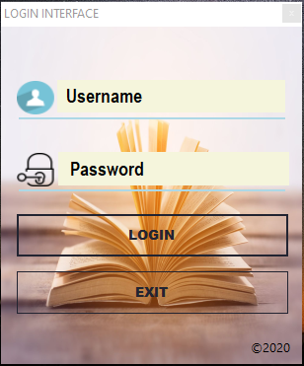

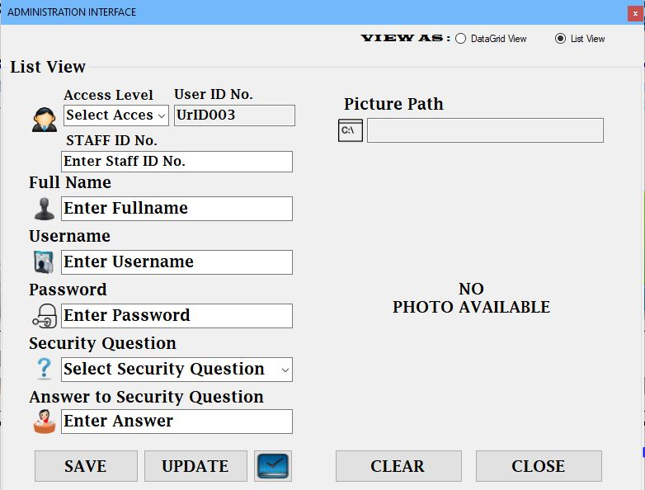**NEW USER FORM**

**NEW MEMBER FORM**

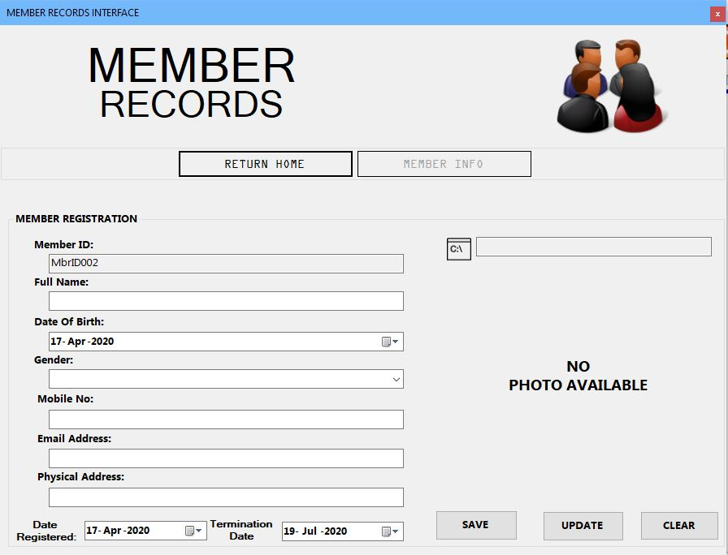

**2.4 DATA STRUCTURES**

**FILE DESIGN**

**TABLES IN DESIGN VIEW**

**LOGIN**

|  |  |  |  |  |
| --- | --- | --- | --- | --- |
| Field Name | Data Type & Length | Validation | Description | Field Width |
| Username | Text (15) | Numerical values must not be accepted and fields must not be empty | Holds the name the user | 20 |
| Password | Text (25) | Must be at least 10 characters long and fields must not be empty | Holds a set of alpha-numeric characters used to gain access to the system | 30 |

**NEW USER**

|  |  |  |  |  |
| --- | --- | --- | --- | --- |
| Field Name | Data Type & Length | Validation | Description | Example |
| Username | Text (15) | Numerical values must not be accepted and fields must not be empty | Holds the name the user | 20 |
| Password | Text (25) | Must be at least 10 characters long and fields must not be empty | Holds a set of alpha-numeric characters used to gain access to the system | 30 |
| Security Question | Text (40) | Characters only | Question used for verification during password recovery | 30 |
| Answer | Text (15) | Only accepts alpha numeric characters | Holds answer to the question chosen for password verification | 45 |
| User ID | Text (15) | Must not be blank | I.D of the User | 20 |
| Gender | Text (8) | Characters only | Stores the gender of the person | 10 |

**NEW MEMBER**

|  |  |  |  |  |
| --- | --- | --- | --- | --- |
| File Name | Data Type & Length | Validation | Description | Field width |
| Full Name | Text (15) | Characters only | Member’s Full name | 30 |
| Member ID | Text (15) | Must not be blank | I.D of the Member | 20 |
| Physical Address | Text (20) | Must not be blank | Address of member | 35 |
| Mobile Number | Number (12) | Must consist of 10-12 digits | Hold the Phone Number of the member | 15 |
| Email Address | Text (15) | Characters only | Holds the email address of the member | 20 |
| Gender | Text (8) | Characters only | Stores the gender of the person | 10 |

**2.5 RELATIONSHIPS**

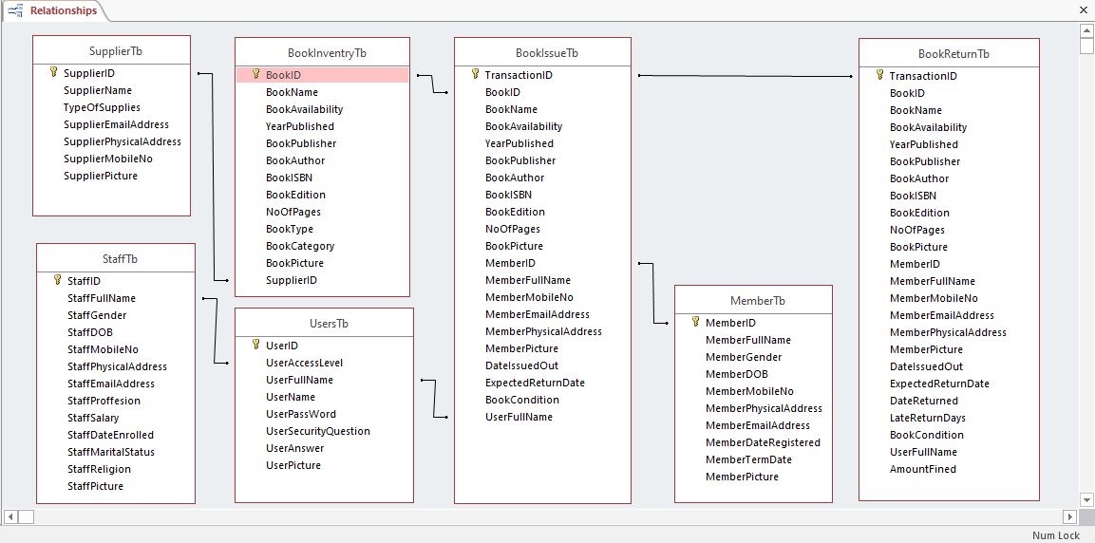

**2.6 OUTPUT DESIGN**

The main goal for a computer system output forms is to show the end user results of system processes and a copy of these results are used for future reference. To the general users the output forms are the main and most direct source of information, therefore should be designed in the simple as possible to improve the ease of use.

**SPECIFICATIONS FOR THE REQUIRED OUTPUT**

**Book issuing**

The system uses automated search criteria which fills in book and members’ details when the book and member ID respectively are entered into the system. All this reduces time consumption as all required details pop up in the designated fields on one go.

* 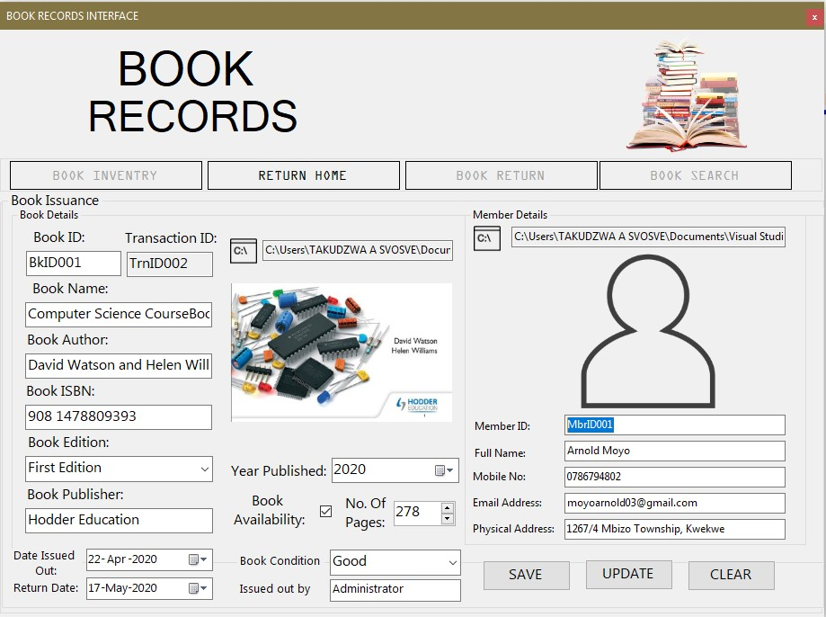A system that eliminates data duplication
* The system has a database management system that use a primary key such that all the books, member and staff are unique to each other. (Primary key: Member ID)

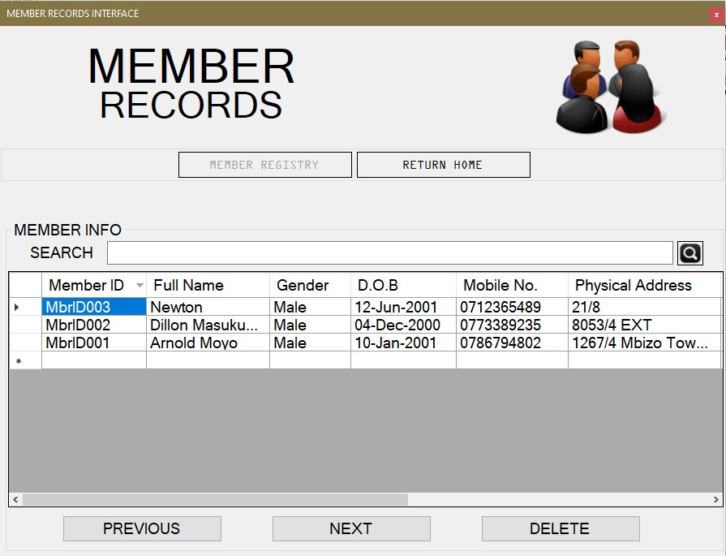

A password protected system



After entering the system username and corresponding password, the user gains access to the system.

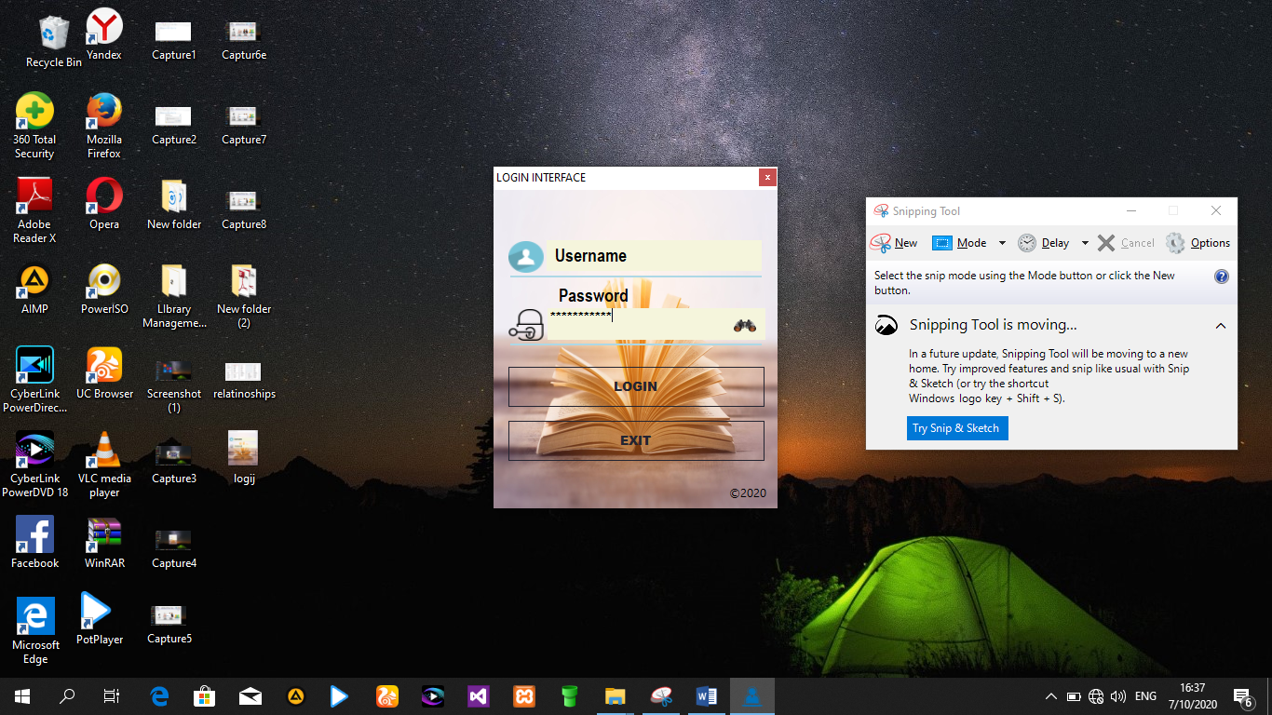

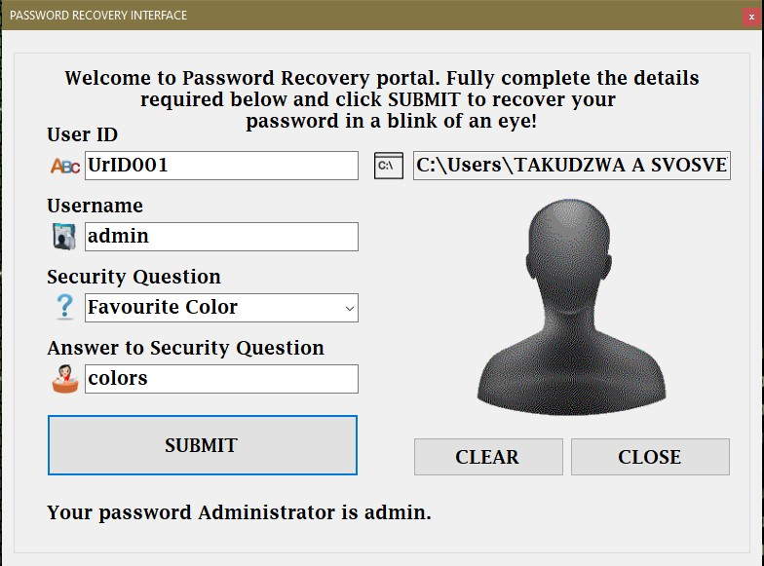In the case that the user forgets the password to the account one can recover it by answering the security question chosen during the creation of the account.

**TEST STRATEGY / TEST PLAN**

**NORMAL DATA**

|  |  |  |  |  |  |
| --- | --- | --- | --- | --- | --- |
| Test Name | Purpose | Test Data | Expected Result | Expected outcome | Actual outcome |
| Valid Username, Valid password | To determine whether the given password and username are correct | Correct password and correct username | Logging in message | Accept | Accept |

**EXTREME DATA**

|  |  |  |  |  |  |
| --- | --- | --- | --- | --- | --- |
| Test Name | Purpose | Test Data | Expected Result | Expected outcome | Actual outcome |
| Invalid password | To determine if the given password corresponds to the username | Correct username,  Incorrect password | Error message appears depicting that the is wrong for the given username | Reject | Reject |

**ABNORMAL DATA**

|  |  |  |  |  |  |
| --- | --- | --- | --- | --- | --- |
| Test Name | Purpose | Test Data | Expected Result | Expected outcome | Actual outcome |
| Blank password and username fields | To check if the system can recognize that the fields are empty |  | Error message  Depicting that the username and corresponding password must entered | Reject | Reject |

**3. SECTION C: SOFTWARE DEVELOPMENT**

**Techniques that improve the structure of the code**

Private Sub sAvEdAtA()

'Declaring variables

Dim ctr, i As Integer

Dim usrname As String = ""

ds.Clear()

str = "select * from UsersTb"

cmd = New OleDbCommand(str, cn)

da.SelectCommand = cmd

da.Fill(ds, "UsersTb")

ctr = ds.Tables("UsersTb").Rows.Count – 1

For i = 0 To ctr

If TextBox4.Text = ds.Tables("UsersTb").Rows(i)(2).ToString Then

usrname = ds.Tables("UsersTb").Rows(i)(2).ToString

End If

Next

If usrname.Contains(TextBox4.Text) Then

'output if User Account already exists

MsgBox("User Account already exists.", MsgBoxStyle.OkOnly + MsgBoxStyle.Exclamation, "Operation Failed")

Else

Try

'initialisation of global variable

cmd = New OleDbCommand

cmd.CommandText = " insert into UsersTb values (@UserID,@UserAccessLevel,@UserFullName,@UserName,@UserPassWord,@UserSecurityQuestion,@UserAnswer,@UserPicture) "

cmd.Parameters.AddWithValue("@UserID", TextBox7.Text)

cmd.Parameters.AddWithValue("@UserAccessLevel", ComboBox1.Text)

cmd.Parameters.AddWithValue("@UserFullName", TextBox4.Text)

cmd.Parameters.AddWithValue("@UserName", TextBox2.Text)

cmd.Parameters.AddWithValue("@UserPassWord", TextBox3.Text)

cmd.Parameters.AddWithValue("@UserSecurityQuestion", ComboBox2.Text)

cmd.Parameters.AddWithValue("@UserAnswer", TextBox5.Text)

cmd.Parameters.AddWithValue("@UserPicture", TextBox6.Text)

cmd.Connection = cn

cmd.ExecuteNonQuery()

'output if method is successful

MsgBox("New User Account successfully added.", MsgBoxStyle.OkOnly + MsgBoxStyle.Information, "Operation Successful")

Catch ex As Exception

'output if method is unsuccessful

MsgBox("Failed to add new Account. Please try again.", MsgBoxStyle.OkOnly + MsgBoxStyle.Exclamation, "Operation Failed")

End Try 'closing Try statement

End If 'closing If statement

End Sub

**3.1 TECHNICAL DOCUMENTATION**

**3.1.1 Pseudo code for Login**

Start  
Enter username  
Enter password

Select mode  
If username = user (x) and password = pass (x) and mode = ADMIN Then  
 Show Administration Form  
Elseif username = user (x) and password = pass (x) and mode = USER Then  
 Show User Form  
Else   
 Show message (login error)

End if  
End

**Pseudo code for New User**

Start

Select Access Level

Enter Staff ID Number

Enter Username

Enter Password

Select Security Question

Enter Answer

If Staff ID number already exists Then

Show message (Staff already has a User Account.)  
 Else  
 Show message (New User Account created)

End if  
End

**Pseudo code for password recovery**

Start

Enter User ID

Enter Username

Select Security Question

Enter Answer

If Access Level = ADMIN Then

If answer = correct Then

Show password

Else

Show message (Incorrect Answer)

Else

Show message (Not eligible to view password)

End if

End

**3.1.2 Flow Charts**

**LOGIN**



**CREATE AN ACCOUNT**



**DELETE USER**



**3.2 CODE LISTING**

**CODE FOR LOGIN**

Sub enable()

Form2.Button5.Show()

Form2.Button6.Show()

Form2.PictureBox3.Location = New System.Drawing.Point(45, 222)

Form2.PictureBox4.Location = New System.Drawing.Point(729, 222)

End Sub

Sub disable()

Form2.Button5.Hide()

Form2.Button6.Hide()

Form2.PictureBox3.Location = New System.Drawing.Point(45, 282)

Form2.PictureBox4.Location = New System.Drawing.Point(729, 282)

Form3.Button1.Hide()

Form3.Button2.Location = New System.Drawing.Point(124, 9)

Form3.Button3.Location = New System.Drawing.Point(344, 9)

Form3.Button4.Location = New System.Drawing.Point(560, 9)

End Sub

Sub increment()

ProgressBar1.Value = ProgressBar1.Value + 10

If ProgressBar1.Value >= 25 Then

Timer1.Enabled = False

Me.Hide()

Form2.Show()

MsgBox("Login Successful." + vbNewLine + "Welcome " + txtusername.Text + ".", MsgBoxStyle.OkOnly + MsgBoxStyle.Information, "Success")

ProgressBar1.Value = 0

End If

End Sub

Sub err()

Dim iresponse As MsgBoxResult

ProgressBar1.Value = ProgressBar1.Value + 10

If ProgressBar1.Value >= 15 Then

Timer1.Enabled = False

Me.Cursor = Cursors.AppStarting

iresponse = MsgBox("Incorrect Details. Try Again!", MsgBoxStyle.OkOnly + MsgBoxStyle.Critical, "Failed!")

ProgressBar1.Value = 0

If iresponse = MsgBoxResult.Ok Then

Me.Cursor = Cursors.Arrow

lblfgpass.Show()

End If

End If

End Sub

Private Sub Login_Click(sender As Object, e As EventArgs) Handles btenter.Click

If txtusername.Text = Nothing And txtpass.Text = Nothing Then

lblfgpass.Hide()

MsgBox("Enter Details to Proceed.", MsgBoxStyle.OkOnly + MsgBoxStyle.Information, "LOGIN PROMPT")

ElseIf txtusername.Text = Nothing Or txtpass.Text = Nothing Then

lblfgpass.Hide()

MsgBox("Enter Complete Details to Proceed.", MsgBoxStyle.OkOnly + MsgBoxStyle.Information, "LOGIN PROMPT")

Else

Timer1.Enabled = True

lblfgpass.Hide()

End If

End Sub

Private Sub Timer1_Tick(sender As Object, e As EventArgs) Handles Timer1.Tick

Dim userfllname As String

Dim ctr, i As Integer

Dim che As Integer = 0

Dim emp As String = ""

ds.Clear()

str = "select * from UsersTb"

cmd = New OleDbCommand(str, cn)

da.SelectCommand = cmd

da.Fill(ds, "UsersTb")

ctr = ds.Tables("UsersTb").Rows.Count - 1

For i = 0 To ctr

If ds.Tables("UsersTb").Rows(i)(3).ToString = txtusername.Text And ds.Tables("UsersTb").Rows(i)(4).ToString = txtpass.Text Then

'che = 1

emp = ds.Tables("UsersTb").Rows(i)(1).ToString

userfllname = ds.Tables("UsersTb").Rows(i)(2).ToString

txtuserfullname.Text = userfllname

End If

Next

If emp = "ADMIN" Then

Me.Cursor = Cursors.AppStarting

increment()

enable()

Form2.Label3.Text = "Logged In As: ADMIN"

ElseIf emp = "USER" Then

Me.Cursor = Cursors.AppStarting

increment()

disable()

Form2.Label3.Text = "Logged In As: USER"

Else

ProgressBar1.Value = ProgressBar1.Value + 5

Me.Cursor = Cursors.AppStarting

If ProgressBar1.Value >= 15 Then

err()

Me.Cursor = Cursors.Arrow

End If

End If

End Sub

**Code for password recovery**

Private Sub Button8_Click(sender As Object, e As EventArgs) Handles Button8.Click

If TextBox1.Text = Nothing Or TextBox2.Text = Nothing Or ComboBox2.SelectedItem = Nothing Or TextBox5.Text = Nothing Then

MsgBox("Account Verification details are incomplete." + vbNewLine + "Complete all fields to proceed!", MsgBoxStyle.Exclamation + MsgBoxStyle.OkOnly, "PASSWORD RECOVERY PROMPT")

Else

Timer1.Start()

End If

End Sub

Private Sub Timer1_Tick(sender As Object, e As EventArgs) Handles Timer1.Tick

Dim icont As MsgBoxResult

Dim ctr, i As Integer

Dim che As Integer = 0

Dim emp As String = ""

Dim empaa As String = ""

Dim acclvl As String = ""

ds.Clear()

str = "select * from UsersTb"

cmd = New OleDbCommand(str, cn)

da.SelectCommand = cmd

da.Fill(ds, "UsersTb")

ctr = ds.Tables("UsersTb").Rows.Count - 1

For i = 0 To ctr

If ds.Tables("UsersTb").Rows(i)(0).ToString = TextBox1.Text And ds.Tables("UsersTb").Rows(i)(3).ToString = TextBox2.Text And ds.Tables("UsersTb").Rows(i)(5).ToString = ComboBox2.SelectedItem And ds.Tables("UsersTb").Rows(i)(6).ToString = TextBox5.Text Then

che = 1

emp = ds.Tables("UsersTb").Rows(i)(2).ToString

empaa = ds.Tables("UsersTb").Rows(i)(4).ToString

acclvl = ds.Tables("UsersTb").Rows(i)(1).ToString

TextBox6.Text = ds.Tables("UsersTb").Rows(i)(7).ToString

End If

Next

If acclvl.Contains("ADMIN") Then

Label6.Show()

Label6.Text = "Your password " + emp + " is " + empaa + "."

Else

Timer1.Stop()

TextBox6.Clear()

Label6.Hide()

Label9.Show()

icont = MsgBox("You don't currently have permission to access this page." + vbNewLine + " Click Ok to permanently get access to this page.", MsgBoxStyle.OkCancel + MsgBoxStyle.Exclamation, "SERVER UNAVAILABLE")

If icont = MsgBoxResult.Ok Then

MsgBox("Please visit the Administration for assistance.", MsgBoxStyle.OkOnly + MsgBoxStyle.Information, "SERVER UNAVAILABLE")

End If

End If

Timer1.Stop()

End Sub

**Code for Book Issue**

Private Sub Button9_Click(sender As Object, e As EventArgs) Handles Button9.Click

Dim LastNo As Integer

LastNo = ds.Tables("BookIssueTb").Rows.Count + 1

If LastNo >= 0 Then

BookIDTextBox.Text = "TrnID00" & LastNo

Else

BookIDTextBox.Text = "TrnID00" & 0

End If

Try

cmd = New OleDbCommand

cmd.CommandText = " insert into BookIssueTb values (@TransactionID,@BookID,@BookName,@BookAvailability,@YearPublished,@BookPublisher,@BookAuthor,@BookISBN,@BookEdition,@NoOfPages,@BookPicture,@MemberID,@MemberFullName,@MemberMobileNo,@MemberEmailAddress,@MemberPhysicalAddress,@MemberPicture,@DateIssuedOut,@ExpectedReturnDate,@BookCondition,@UserFullName) "

cmd.Parameters.AddWithValue("@TransactionID", TansactionIDTextBox.Text)

cmd.Parameters.AddWithValue("@BookID", TextBox2.Text)

cmd.Parameters.AddWithValue("@BookName", TextBox6.Text)

cmd.Parameters.AddWithValue("@BookAvailability", CheckBox1.CheckState)

cmd.Parameters.AddWithValue("@YearPublished", DateTimePicker1.Text)

cmd.Parameters.AddWithValue("@BookPublisher", TextBox4.Text)

cmd.Parameters.AddWithValue("@BookAuthor", TextBox1.Text)

cmd.Parameters.AddWithValue("@BookISBN", TextBox3.Text)

cmd.Parameters.AddWithValue("@BookEdition", ComboBox3.Text)

cmd.Parameters.AddWithValue("@NoOfPages", NumericUpDown1.Value)

cmd.Parameters.AddWithValue("@BookPicture", TextBox5.Text)

cmd.Parameters.AddWithValue("@MemberID", MemberIDTextBox.Text)

cmd.Parameters.AddWithValue("@MemberFullName", MemberFullNameTextBox.Text)

cmd.Parameters.AddWithValue("@MemberMobileNo", MemberMobileNoTextBox.Text)

cmd.Parameters.AddWithValue("@MemberEmailAddress", MemberEmailAddressTextBox.Text)

cmd.Parameters.AddWithValue("@MemberPhysicalAddress", MemberPhysicalAddressTextBox.Text)

cmd.Parameters.AddWithValue("@MemberPicture", MemberPictureTextBox.Text)

cmd.Parameters.AddWithValue("@DateIssuedOut", DateIssuedOutTextBox.Text)

cmd.Parameters.AddWithValue("@ExpectedReturnDate", ExpectedReturnDatePicker.Text)

cmd.Parameters.AddWithValue("@BookCondition", BookConditionCombo.Text)

cmd.Parameters.AddWithValue("@UserFullName", UserFullNameTextBox.Text)

cmd.Connection = cn

cmd.ExecuteNonQuery()

MsgBox("Book Issue Transaction Successful..", MsgBoxStyle.OkOnly, "Transaction Successful")

Catch ex As Exception

MsgBox("Transaction Failed. Please try again.", MsgBoxStyle.OkOnly, "Transaction Failed")

End Try

End Sub

**Code for Book Return**

Private Sub Button13_Click(sender As Object, e As EventArgs) Handles Button13.Click

Dim LastNo As Integer

LastNo = ds.Tables("BookReturnTb").Rows.Count + 1

If LastNo >= 0 Then

BookIDTextBox.Text = "TrnID00" & LastNo

Else

BookIDTextBox.Text = "TrnID00" & 0

End If

Try

cmd = New OleDbCommand

cmd.CommandText = " insert into BookReturnTb values (@TransactionID,@BookID,@BookName,@BookAvailability,@YearPublished,@BookPublisher,@BookAuthor,@BookISBN,@BookEdition,@NoOfPages,@BookPicture,@MemberID,@MemberFullName,@MemberMobileNo,@MemberEmailAddress,@MemberPhysicalAddress,@MemberPicture,@DateIssuedOut,@ExpectedReturnDate,@DateReturned,@LateReturnDays,@BookCondition,@UserFullName,@AmountFined) "

cmd.Parameters.AddWithValue("@TransactionID", TextBox14.Text)

cmd.Parameters.AddWithValue("@BookID", TextBox16.Text)

cmd.Parameters.AddWithValue("@BookName", TextBox20.Text)

cmd.Parameters.AddWithValue("@BookAvailability", CheckBox2.CheckState)

cmd.Parameters.AddWithValue("@YearPublished", DateTimePicker4.Text)

cmd.Parameters.AddWithValue("@BookPublisher", TextBox18.Text)

cmd.Parameters.AddWithValue("@BookAuthor", TextBox15.Text)

cmd.Parameters.AddWithValue("@BookISBN", TextBox17.Text)

cmd.Parameters.AddWithValue("@BookEdition", ComboBox2.Text)

cmd.Parameters.AddWithValue("@NoOfPages", NumericUpDown2.Value)

cmd.Parameters.AddWithValue("@BookPicture", TextBox19.Text)

cmd.Parameters.AddWithValue("@MemberID", TextBox8.Text)

cmd.Parameters.AddWithValue("@MemberFullName", TextBox9.Text)

cmd.Parameters.AddWithValue("@MemberMobileNo", TextBox13.Text)

cmd.Parameters.AddWithValue("@MemberEmailAddress", TextBox11.Text)

cmd.Parameters.AddWithValue("@MemberPhysicalAddress", TextBox12.Text)

cmd.Parameters.AddWithValue("@MemberPicture", TextBox10.Text)

cmd.Parameters.AddWithValue("@DateIssuedOut", DateTimePicker3.Text)

cmd.Parameters.AddWithValue("@ExpectedReturnDate", DateTimePicker2.Text)

cmd.Parameters.AddWithValue("@DateReturned", DateReturnedPicker.Text)

cmd.Parameters.AddWithValue("@LateReturnDays", LateReturnDaysTextBox.Text)

cmd.Parameters.AddWithValue("@BookCondition", ComboBox1.Text)

cmd.Parameters.AddWithValue("@UserFullName", TextBox7.Text)

cmd.Parameters.AddWithValue("@AmountFined", AmountFinedTextBox.Text)

cmd.Connection = cn

cmd.ExecuteNonQuery()

MsgBox("Book Return Transaction Successful..", MsgBoxStyle.OkOnly, "Transaction Successful")

Catch ex As Exception

MsgBox("Transaction Failed. Please try again.", MsgBoxStyle.OkOnly, "Transaction Failed")

End Try

End Sub

**3.3 USER DOCUMENTATION**

**(a) INSTALLATION OF THE SYSTEM**

Open the system folder in the disk and run the application named “Kwekwe Library Management System setup”.

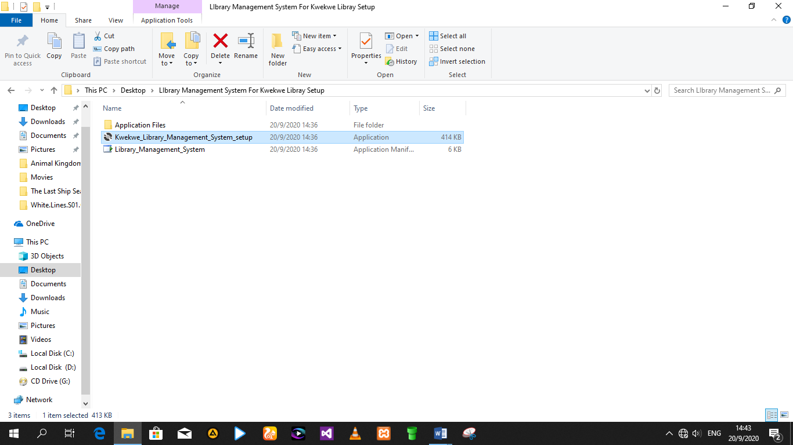

When a dialog opens, click the button Install.

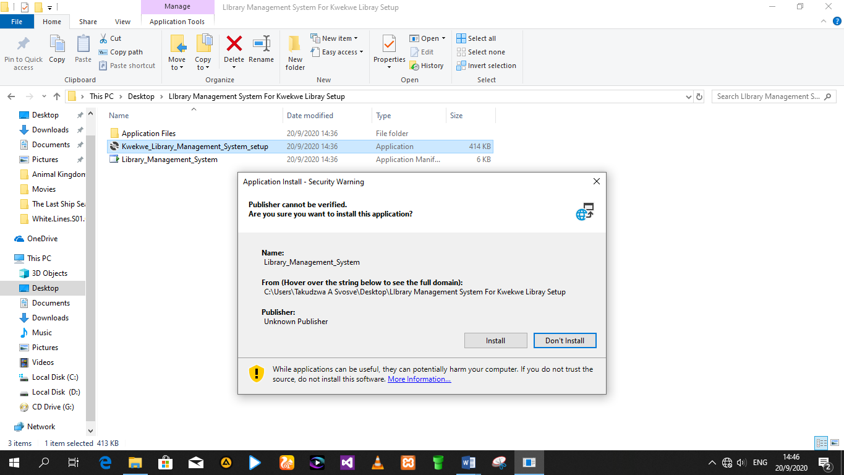

**(b) STARTING THE SYSTEM**

Open the application from your installed computer apps

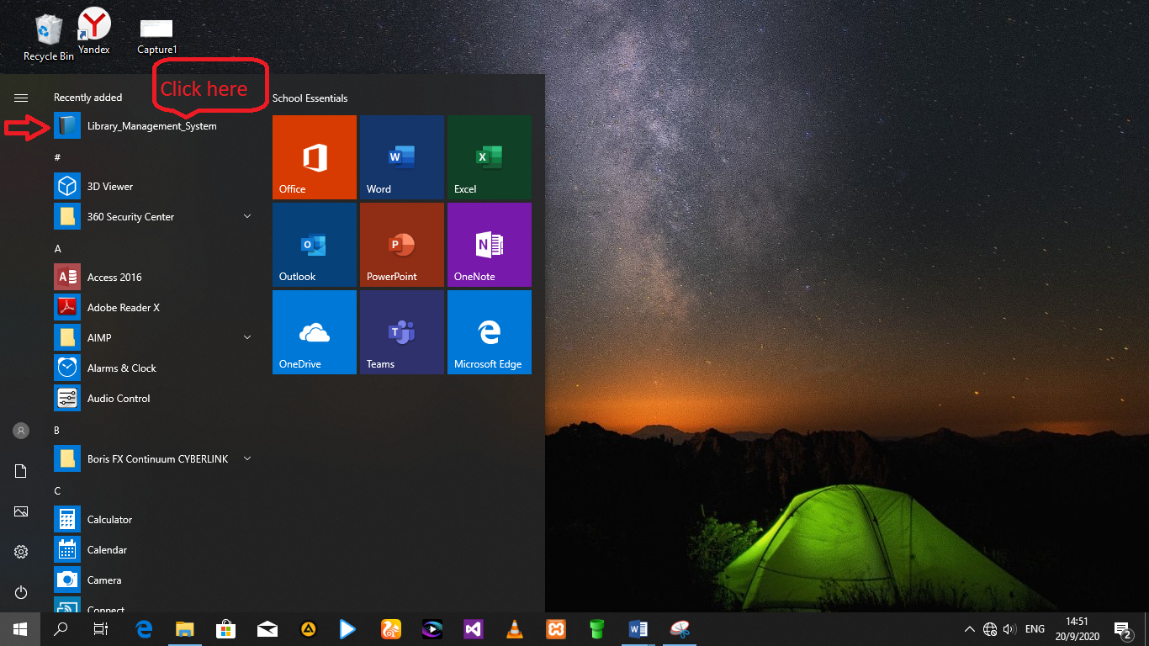

The system

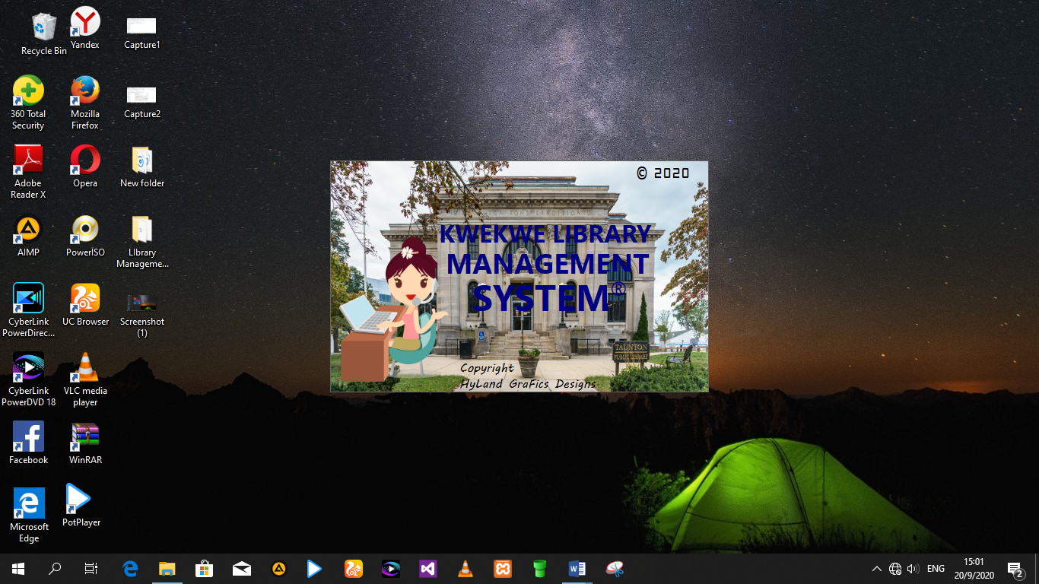

The system will now proceed to the Login Form where the user will be prompted to enter his/her login details

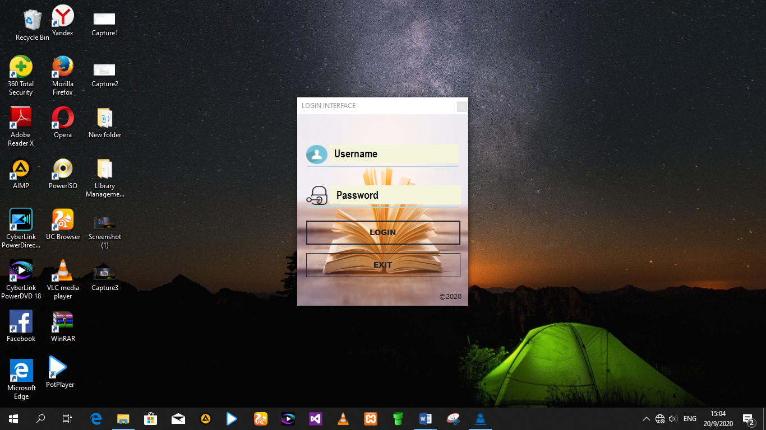

After the user has successfully entered a valid user account, the Main Interface of the system is shown.

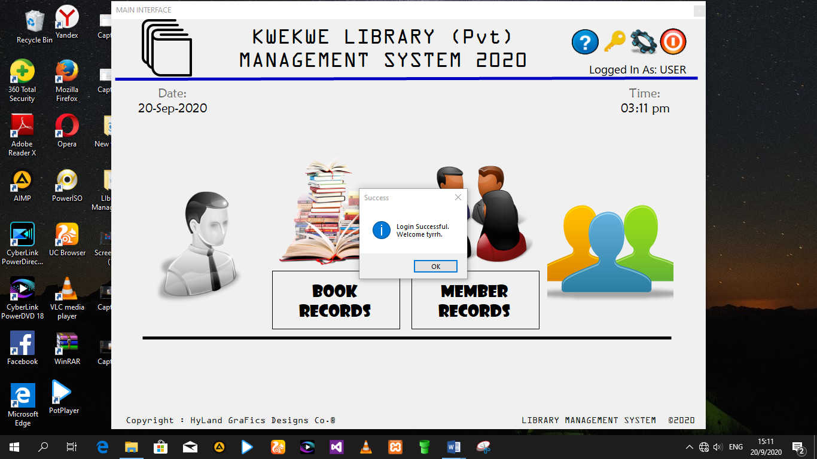

**(c) SYSTEM NAVIGATION**

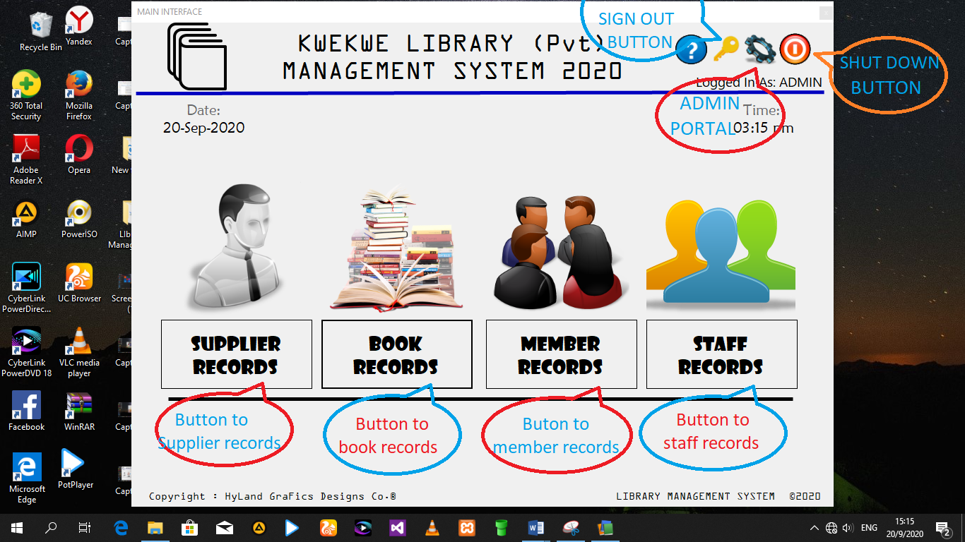

(**d) EXITING THE SYSTEM**

To exit the system, click on Shut down and select Ok

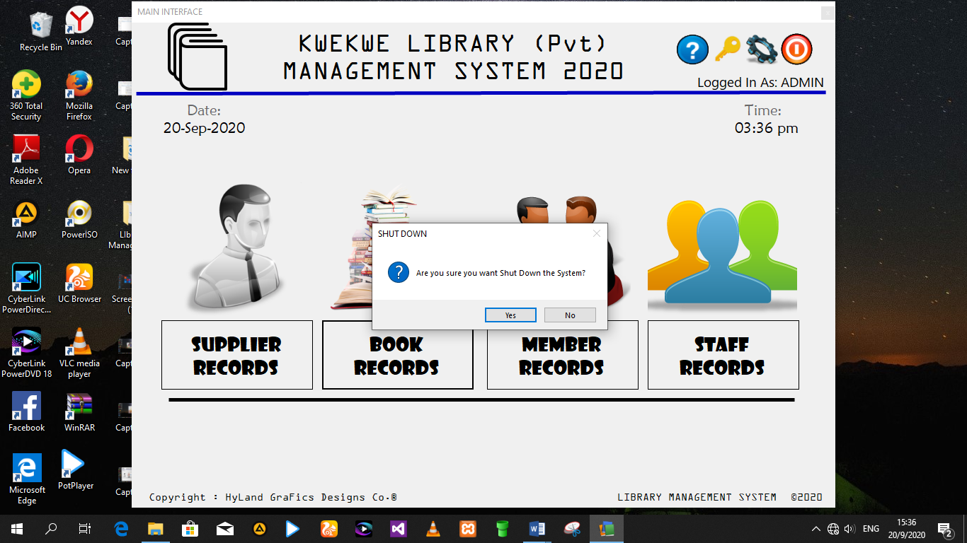

**4.0.0 SECTION D: TESTING AND EVALUATION**

**4.1 USER TESTING**

**Black Box Testing**

This is a set of input that fully exercises the functional requirements of the system. It focuses on the overall functionality of the software. With Black box testing, it will be an attempt to find errors in the following categories; incorrect functions, interface errors, performance errors and initialization errors.

Test Plan

1. Normal data
2. Extreme data
3. Abnormal data

**TEST DATA, ERROR MESSAGES, SAMPLE RUNS &EVALUATION**

|  |  |  |  |  |  |  |
| --- | --- | --- | --- | --- | --- | --- |
| Test No. | Test Field | Reason for Testing | Test Data | Type of Test | Expected Outcome | Actual Outcome |

|  |  |  |  |  |  |  |
| --- | --- | --- | --- | --- | --- | --- |
| 1 | Password | System should detect if password and its length are as required | svosve | Normal | accept | Accepted |
| 2 | Password | System should recognize password length is less than minimum | tee | Extreme | reject | Rejected |
| 3 | Password | Presence check |  | Abnormal | Reject | rejected |

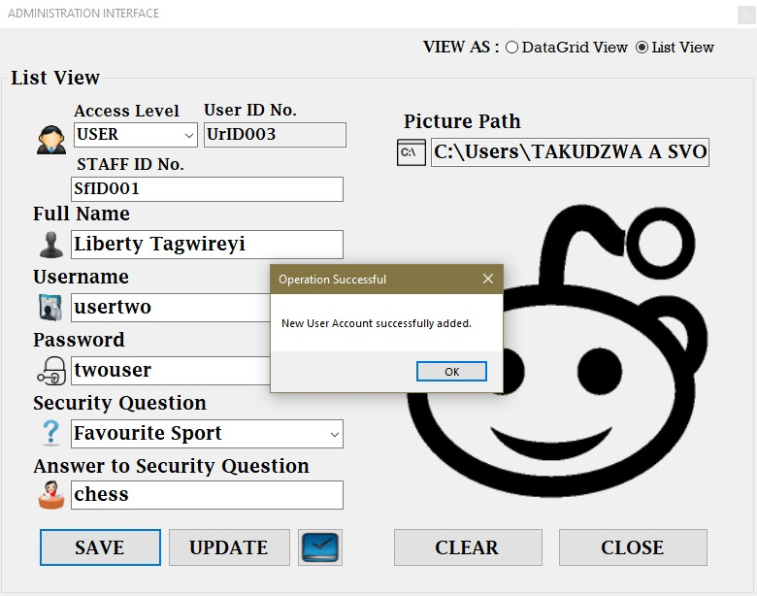**Test for standard data**

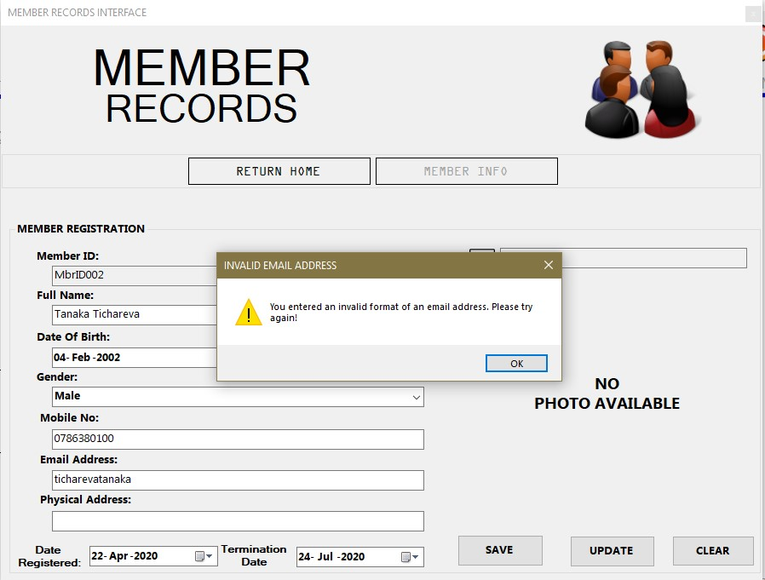**Test for extreme data**

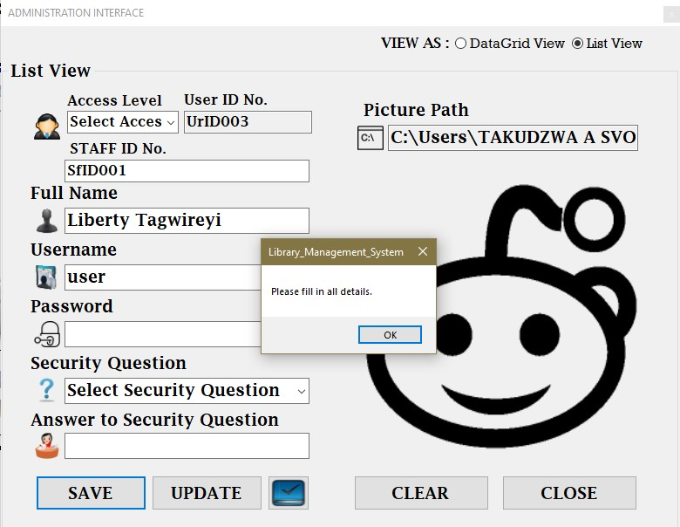**Test for abnormal data**

**4.2 SYSTEM TESTING**

**Ease of use**

All of the system’s resources are on the main interface form and are visible to the user.

**Reliability**

The system has an inbuilt calculator to verify system calculations.

**Effectiveness**

The system has an automation mode which has a higher response time and does system calculations very fast and effectively

**Queries**

Upon a search query, the system produces the query as exactly asked of it and if there is no matching solution, displays the closest solution to the search query.

**4.3 EVALUATION OF THE SYSTEM**

**STRENGTHS**

* The programmer was able to computerize the current manual system.
* The programmer was able to create a system that reduces overhead costs.
* The programmer was able to create a system that completely gets rid of strenuous manual searching of records.
* The programmer was able to create a system that reduces labour and paper work costs.
* The programmer managed to create a secure system which secures details by use of passwords and use of access levels.
* The programmer managed to design a system with a user friendly environment with very high efficiency.

**LIMITATIONS**

* There were frequent power cuts.
* Limited access to technological resources such as the internet to carry out thorough research on the best solution.
* There was not enough time to only focus on the development of the system due to other subjects also requiring my attention.
* Lack of assistance.

**Opportunities for future development**

* The system can be upgraded for online access.
* For better security, biometrics can be introduced to the system
* With adequate time the system can warn borrowers on the availability of books and warn them if their due dates are nearby online.

**APPENDICES**